HOE 1/Assignment #3 Data Exploration by Joshua Troup

1. 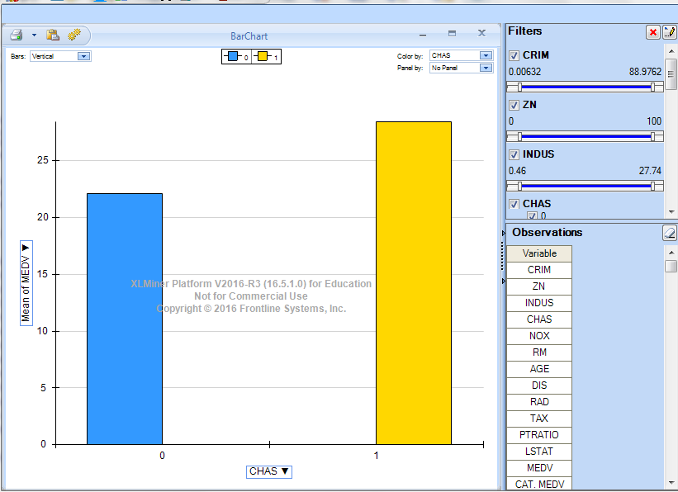

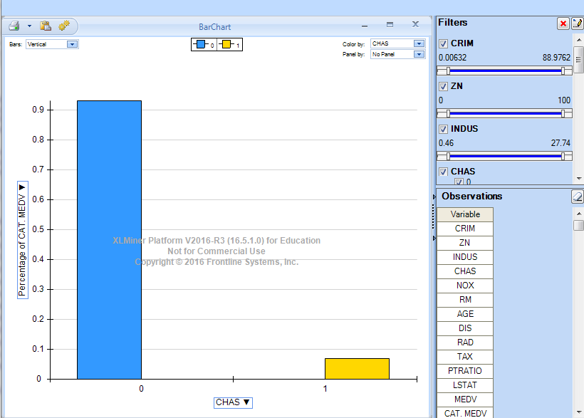

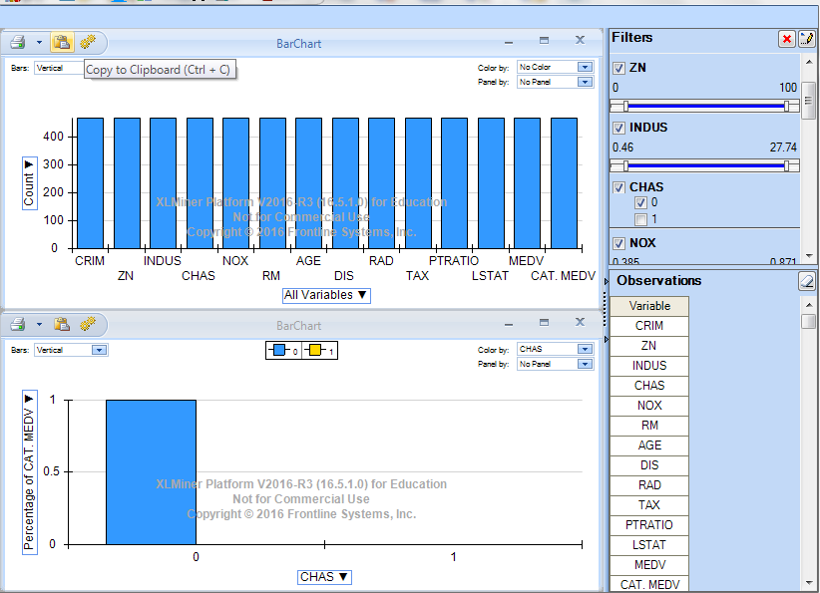

Bar chart

The bars represent the homes in the Boston area that are located close to the Charles River and homes that are not. The first bar (0) shows the average median value of owner occupied homes that are not close to Charles River. The second bar (1) shows the average median value of owner occupied homes that are close to Charles River. The graph indicates the homes closer to the Charles River are more expensive than the homes not located near the river. (0) bar shows a mean of approximately 22 while (1) bar shows a mean of a higher number closer to 28. The majority of the houses are located far away from the Charles River based on the Percentage of CAT MEDV graph.

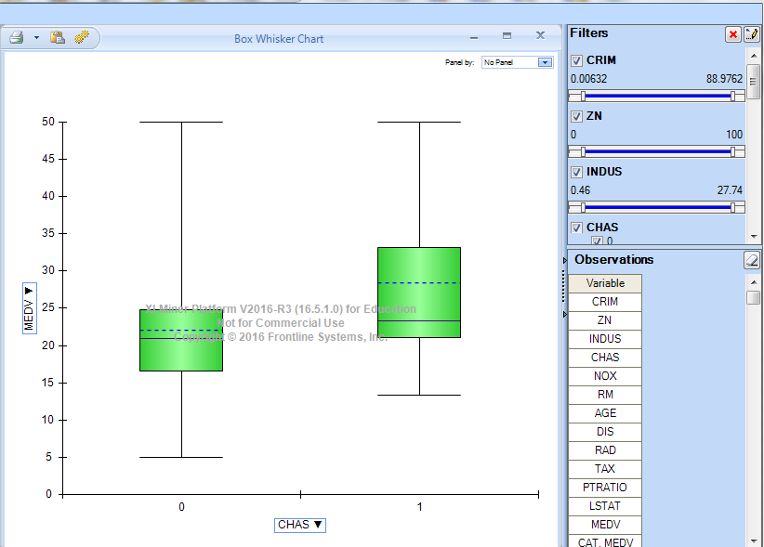

1. Bar (0) Bar (1)

75th—24.8 33.15

25th—16.6 21.1

Max-50 50

Min-5 13.4

Median-20.9 23.3

Mean-22.09 28.44

The box plot chart shows homes near the Charles River start out much higher but homes near and not near can be similar price on the higher end of values. The mean or average of the homes along the river is greater than the average of the homes not along the river. The dummy variable CHAS is a good predicator of home values.

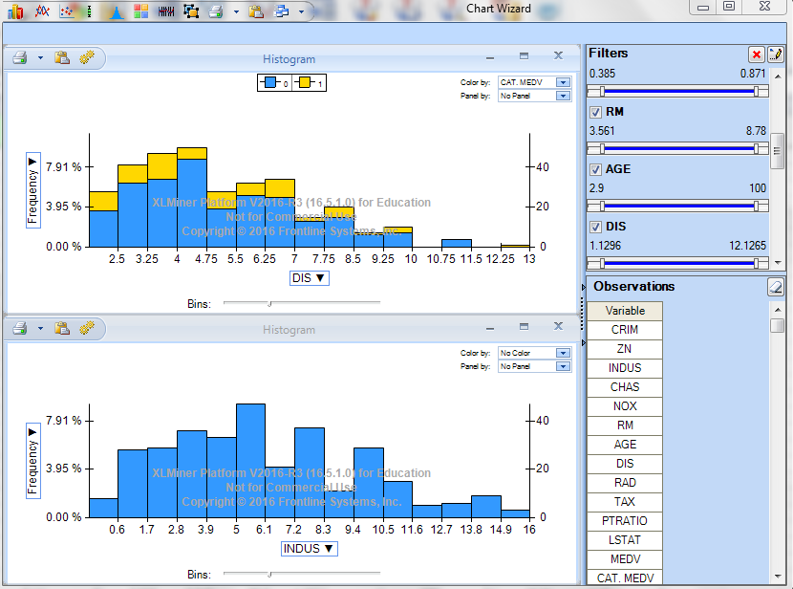

1. The graph does not change.

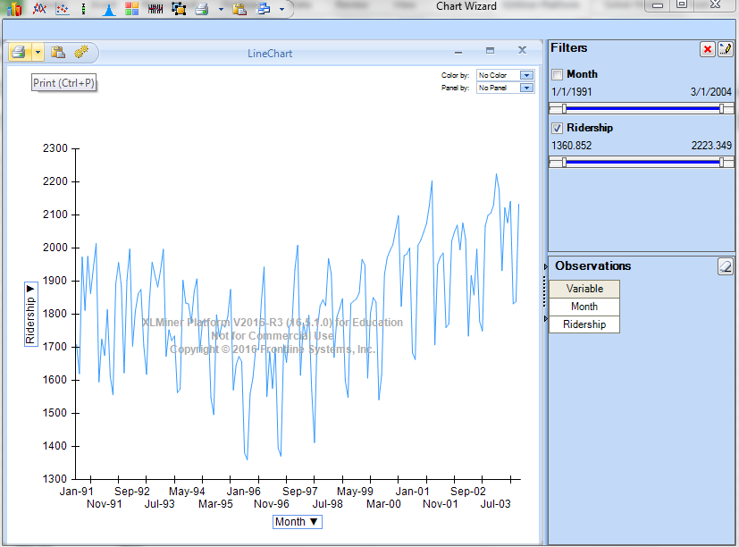

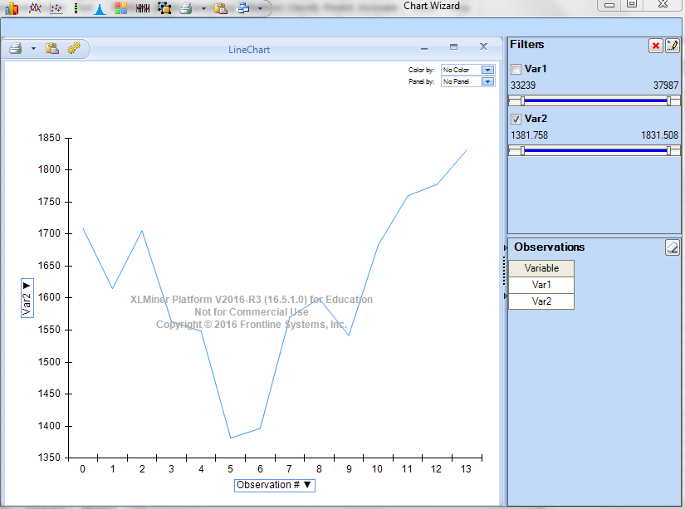

1. The chart shows a decrease starting in Jan 94 and hitting the lowest in Jan 96. The gradual increase started the next year with the last year Jan 04 being the highest value.

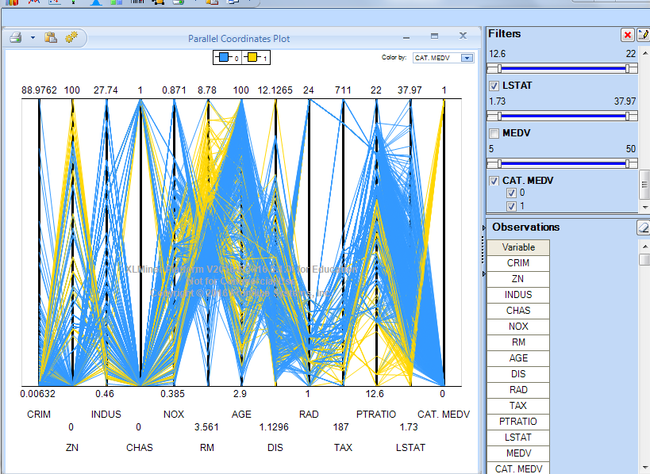

1. There are more houses with of a value of 0 for CAT.MEDV than with a value of 1. The more expensive the home is the lower the CRIM, LSAT, and higher RM.

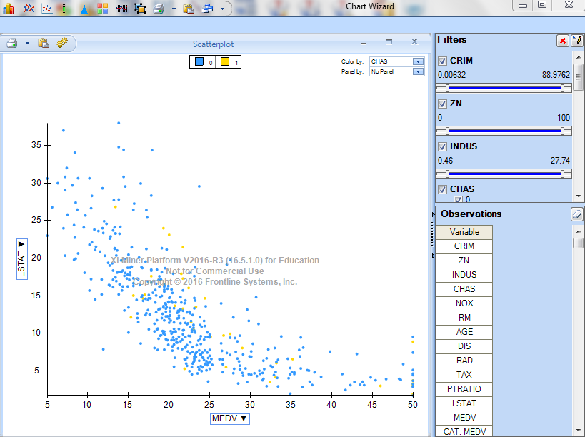

1. The graph indicates the homes near the river are more expensive.

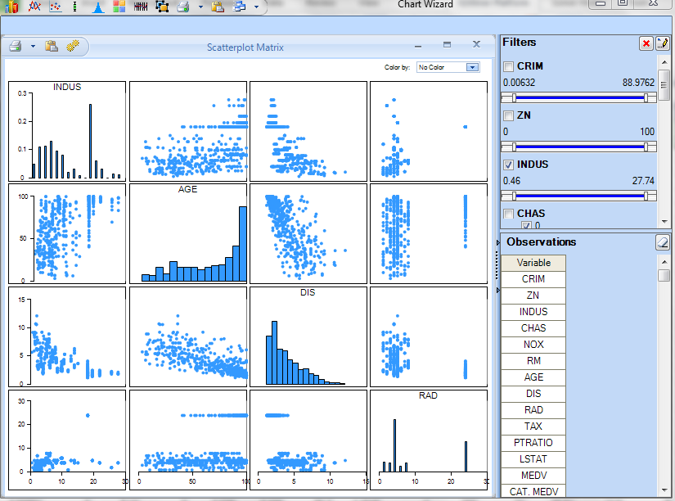

1. The scatterplot matrix shows a pairwise relationship between the variables AGE and DIS.

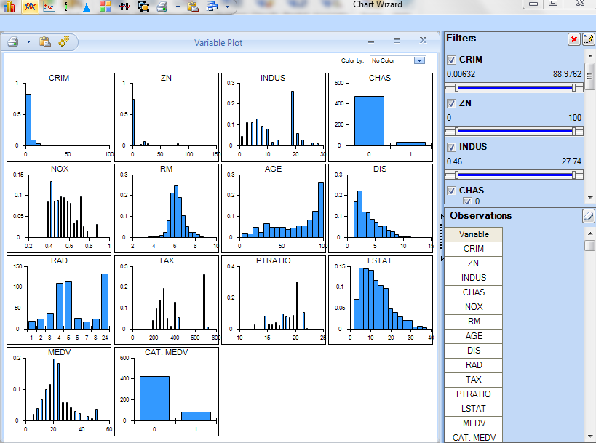

H. CAT.MEDV and CHAS have similar charts showing the difference between the values of home along the river and not near the river. CRIM shows the crime rate to be much higher where the houses are not near the river being less in value compared to the Charles River home properties. NOX, AGE, TAX, and PTRATIO are variables that are not relevant in the overall value of homes in the Boston housing industry. Tax is an unknown factor and age is not a numerical attribute pertaining to value of home. I feel the NOX and PTRATIO are not relevant variables to include in the study as well. The remaining variables in the data represent an accurate data set.